# Branch Education

## Definition

**# Source**: **Chatgpt (GPT-5-Standard) at [8/27/2025]**

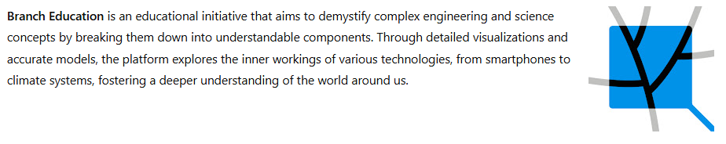

**Branch Education** is an educational initiative that aims to demystify complex engineering and science concepts by breaking them down into understandable components. Through detailed visualizations and accurate models, the platform explores the inner workings of various technologies, from smartphones to climate systems, fostering a deeper understanding of the world around us.

## Key Highlights

**# Source**: **Chatgpt (GPT-5-Standard) at [8/27/2025]**

* **Content Focus**: In-depth explanations of engineering and science topics, utilizing 3D models and visualized physics.
* **Educational Approach**: Adopts a "branched" structure, exploring subcomponents of broader systems to provide comprehensive insights.
* **Global Reach**: Videos are translated into multiple languages, including Russian, Arabic, Hindi, and Chinese, to cater to a diverse audience.
* **Platform**: Primarily available on [branch.education](https://branch.education/), offering a user-friendly interface for learners.([Branch Education](https://branch.education/?utm_source=chatgpt.com), [Born to Engineer](https://www.borntoengineer.com/top-engineering-videos-branch-education?utm_source=chatgpt.com), [Branch Education](https://branch.education/the-plan?utm_source=chatgpt.com))

## Summary Table

**# Source**: **Chatgpt (GPT-5-Standard) at [8/27/2025]**

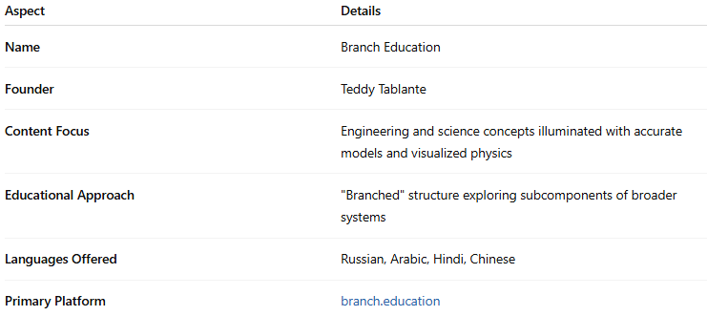

| **Aspect** | **Details** |
| --- | --- |
| **Name** | Branch Education |
| **Founder** | Teddy Tablante |
| **Content Focus** | Engineering and science concepts illuminated with accurate models and visualized physics |
| **Educational Approach** | "Branched" structure exploring subcomponents of broader systems |
| **Languages Offered** | Russian, Arabic, Hindi, Chinese |
| **Primary Platform** | [branch.education](https://branch.education/) |

Branch Education stands out for its commitment to making complex topics accessible and engaging, encouraging viewers to explore and understand the intricacies of the world through a structured and visual approach.